Tenda F3--How to Setup PPPOE Mode

Note: If you have no idea about what is the connection type of your network, please contact the ISP (Internet Service Provider) to confirm it.

Step 1: Connect the broadband line to the WAN port of router, and then connect your computer to LAN1/LAN2/LAN3 port by a cable. Physical connection as bellow:

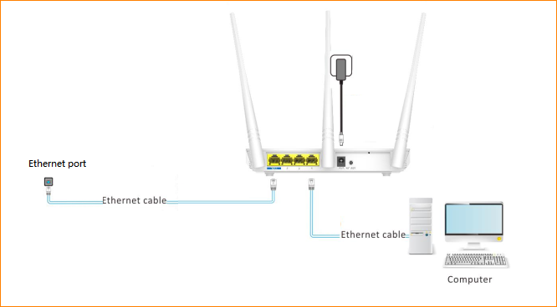

Step 2: Configure your computer in dynamic IP, for more detail, click Here.

Step 3: Setup the router

- Open a browser then type “192.168.0.1” into the Address Bar, press Enter, and you can see the quickest setting page.

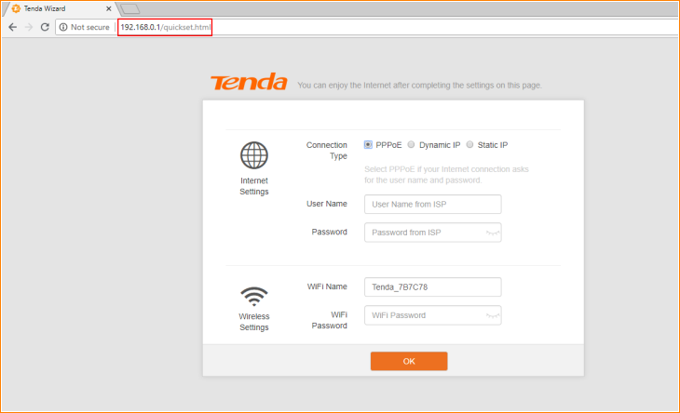

- Select “PPPOE” option. Type the username and password from your ISP, and tap “OK”.

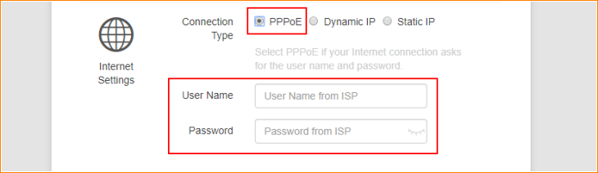

Note: If you do not know or forget your user name or password, please call your ISP to check it.

3. Setup the name and password of your WI-FI signal in “Wireless Settings”. Set them as you want, then tap “OK” to save this setting.

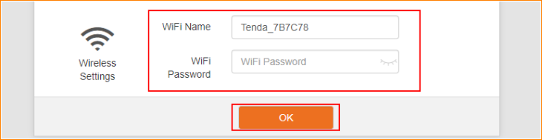

Note: If you do not want to setup password for your Wi-Fi, keep the “WiFi password” bar empty.

- Then the page will pop into homepage of your F3. You can see your Wi-Fi status in “Status”. If the information is shown as below, you can surf the internet now.

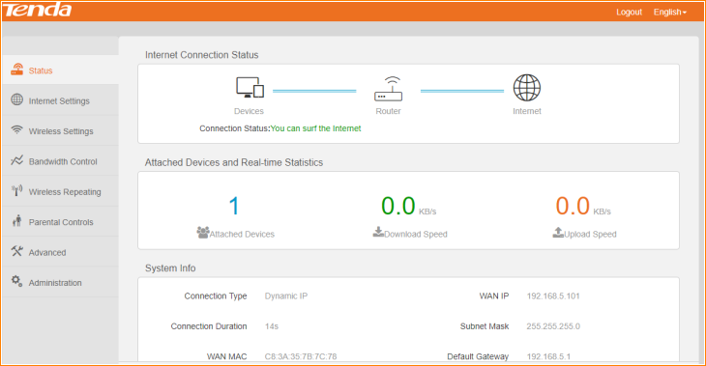

NOTE: When the Connection Status is “connecting”, please try the steps as below.

1. Tap “Administration”“WAN Parameters” “Clone MAC”.
Some ISPs will bind your broadband account info and a specified MAC address of your computer together. If you can only access the Internet with a specified computer without a Router, you can try cloning MAC address for normal Internet access. By default, it clones the factory MAC address (the MAC address of the router). If you want to clone the MAC address of the current attached computer, select “manual” and input the MAC address of the current attached computer on its right. Then tap “OK” to save this setting.

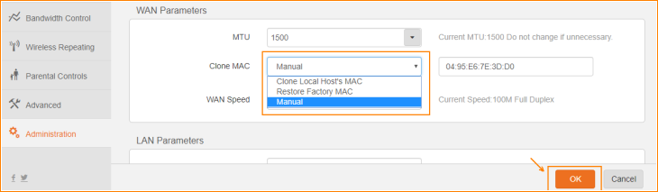

2. Tap “Administration”“WAN Parameters” “WAN speed”.
In WAN Parameters, pelase choose WAN Speed in the drop-menu. Then click OK to save the settings.
By default, the WAN rate is set as “Auto”. Generally, it is not advisable to change the default value. When the cable length between your Router and the remote device (modem, Router, etc.) is relatively long, you can set WAN rate to 10M FDX or 10MHDX to enhance transmission rate.

